**The Diversity Immigrant Visa (DV) program, also called the U.S. green card lottery, is a government-run lottery to get a U.S. green card (permanent residence). Each year, the program offers up to 55,000 visas to people from countries with low immigration to the U.S. who meet basic education requirements.**

# Who Can Apply?

To be eligible, you, your spouse, or your parent must have been born in a country that sent less than 50,000 immigrants to the United States in the previous five years. The U.S. Department of State (DOS), which administers the program, publishes a

full list of eligible countries on its website each year.

Applicants must also prove that they have:

* at least a high school education or its equivalent; or
* two years of work experience within the past five years in an occupation that requires at least two years of training or experience.
  + Instructions to determine if your job is eligible can be found on the [**DOS website**](https://travel.state.gov/content/travel/en/us-visas/immigrate/diversity-visa-program-entry/diversity-visa-if-you-are-selected/diversity-visa-confirm-your-qualifications.html).

You can apply for the DV program in the United States or overseas.

# How Do I Apply?

To apply, you must submit your application online

at the DOS Electronic Diversity Visa (E-DV) website: [**https://dvprogram.state.gov**](https://dvprogram.state.gov/). Paper applications are not allowed. There is no fee to enter the DV program, but if you are selected and scheduled for an inter- view, you will need to pay a visa application fee.

# When Can I Apply?

Every year, there’s a specific time to apply, which is announced on the DOS website. The application pe- riod usually lasts a few weeks, from early October to early November. The entry form can only be submit- ted during this time. It’s best to apply early to avoid technical issues.

# How Will I Know If I Have Been Selected for the DV Program?

DOS randomly chooses people for the DV program each year using a computer lottery. You can check if you’ve been selected by using the confirmation

number you got when you applied. Go to the Entrant Status Check portal at [**https://dvprogram.state.gov/**](https://dvprogram.state.gov/ESC/)[**ESC/**](https://dvprogram.state.gov/ESC/), usually starting in early May. If you’re selected, you’ll need to take more steps, like submitting documents, getting a medical exam, and attending an interview.

DOS releases detailed instructions each year about the diversity visa lottery process: [**https://travel.**](https://travel.state.gov/content/travel/en/us-visas/immigrate/diversity-visa-program-entry/diversity-visa-instructions.html)[**state.gov/content/travel/en/us-visas/immigrate/**](https://travel.state.gov/content/travel/en/us-visas/immigrate/diversity-visa-program-entry/diversity-visa-instructions.html)[**diversity-visa-program-entry/diversity-visa-**](https://travel.state.gov/content/travel/en/us-visas/immigrate/diversity-visa-program-entry/diversity-visa-instructions.html)[**instructions.html**](https://travel.state.gov/content/travel/en/us-visas/immigrate/diversity-visa-program-entry/diversity-visa-instructions.html)

We encourage you to contact our office at [NAME] at [NUMBER] if you have any questions.

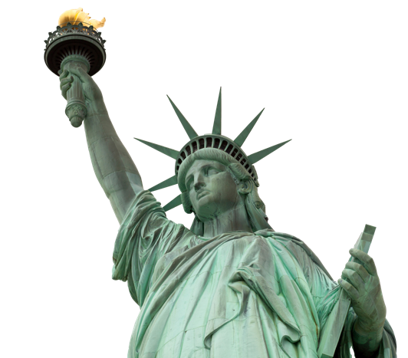

**What Is the Diversity Visa Lottery?**



**©2025 American Immigration Lawyers Association**

**#AILAStandsWithImmigrants**

AILA is the national bar association of immigration lawyers comprised of over 15,000 members located in every state of the United States and worldwide.

*This flyer is intended for general information purposes only and does not constitute legal advice. You should not act or rely on any information in this flyer without seeking the advice of a competent, licensed immigration attorney.*