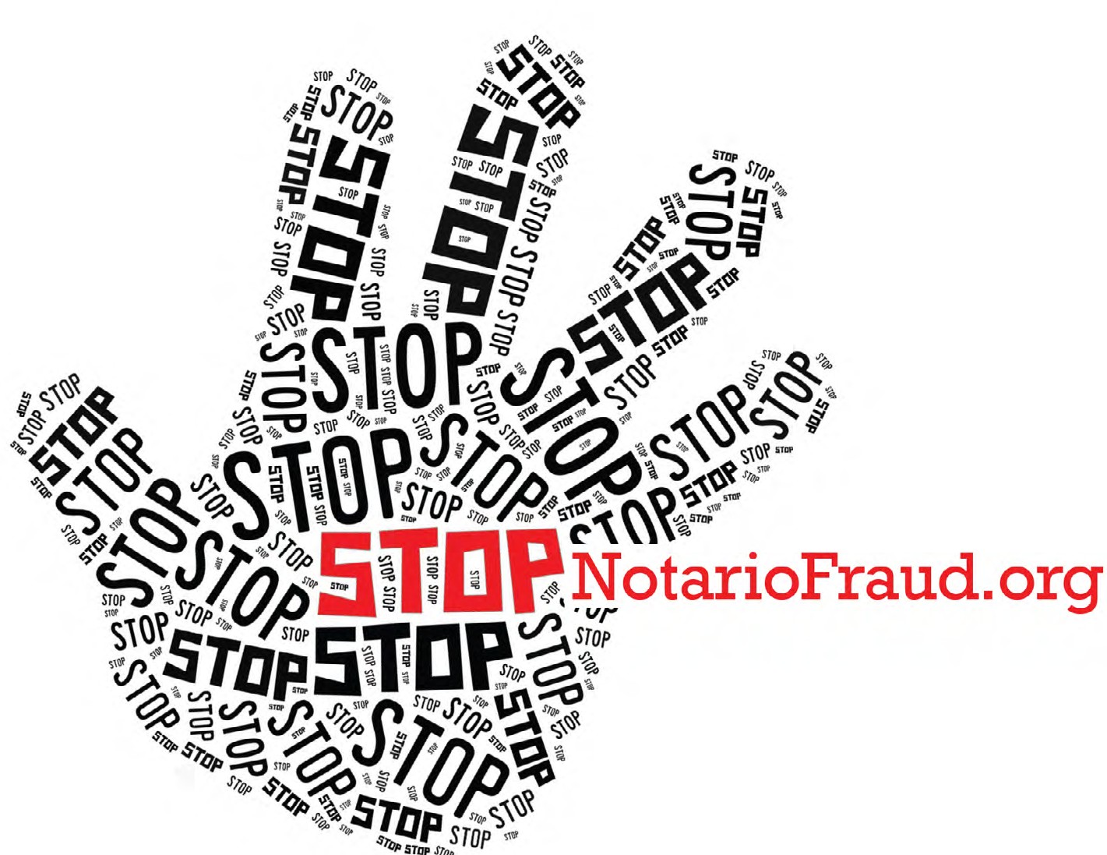

Beware of Immigration Scams!

STOP! Despite the excitement about new White House immigration announcements, it is more important than ever to seek advice from a qualified immigration attorney or an accredited representative about your specific situation.

BE PATIENT and take the time to find the right help. Details of how to apply for the new program are not yet available. The wrong advice could harm your chances of staying in the United States, getting lawful status, or becoming a U.S. citizen.

DON’T BE FOOLED by notarios, consultants, or immigration scams promising immediate results or special solutions in order to steal your money. Many unscrupulous notarios cost more than licensed attorneys! If you are unsure if someone is qualified to help, ask for proof of their credentials, and retain a copy of that evidence.

USE AILA’s Find an Immigration Lawyer Search, www.ailalawyer.org, to find a qualified immigration attorney. Or find an accredited representative at www.justice.gov/eoir/recognized-organizations- and-accredited-representatives-roster-state-and-city

TALK to a qualified immigration attorney, ASK questions before making payments, and REPORT
notarios who are trying to take advantage of you or your family.

For more information on avoiding scams and reporting notarios, visit www.stopnotariofraud.org.

If you have any questions, we encourage you to contact our office at [NAME] at [NUMBER] or [EMAIL].
